XABA MOUNTAINEERING CLUB 2023 -2024

END OF YEAR ACCOUNTS August 2024

|  |  |  |  |
| --- | --- | --- | --- |
| **Income** |  | **Expenditure** | **amount** |
| Carried forward from Aug ‘23 | 7022.40 | Calor tank rental | 102.95 |
| Subscriptions | 1200.00 | Dehumidifier repair | 55.04 |
| Standing Order Subscriptions | 2810.00 | Dinner | 1254.00 |
| Hut fees | 490.00 | Dinner refunds ( Covid) | 99.00 |
| Dinner | 1353.00 | Electricity Scottish power | 865.00 |
| Double subs paid in error & donation | 40.00 | double subs refund | 50.00 |
|  |  | HSBC Charges | 62.80 |
|  |  | Water heater service & certificate | 90.00 |
| Pam Wood Donation for Solicitors fees | 17412.60 | NFU Insurance | 690.33 |
| Ring Fenced anon | 1000.00 | Lawn mower service & fuel | 128.76 |
|  |  | Shower repairs | 341.06 |
|  |  | Postage | 71.65 |
|  |  | Muckle LLP solicitor fees | 17412.60 |
|  |  | Work weekend materials | 146.88 |
|  |  | Misc expenses Duffy | 41.67 |
|  |  | Welsh water | 73.35 |
|  |  | WEB hosting fees | 85.04 |
|  |  |  |  |
|  |  |  |  |
|  |  |  |  |
|  |  | Total expenditure | £ 21,570.13 |
|  |  | Bank Balance as of 2nd Aug 2024 carriedfwd to 2024 - 2025 | £ 9,757.87 |
|  |  |  |  |
|  |  |  |  |
|  |  |  |  |
|  |  |  |  |
|  |  |  |  |
| Total income & carried in from 2023 | £ 31,328.00 | Total expenditure& bank balance 2 Aug 2024 | £ 31,328.00 |

Duffy 4 August 2024

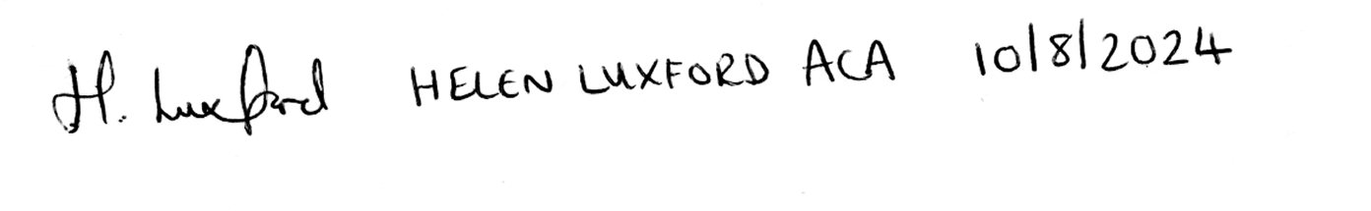

XABA Mountaineering Club

Treasurer’s report August 2024

Unlike last year it has beena year of minimal expenditure from Club funds . Just essential repairs and maintenance have been carried out.

NFU insurance cost have increased significantly again but no better quotes were available.

Shower repairs item includes 2 New Mira bar shower mixers were installed as the originals were proving temperamental as well as a Perspex upstand in front washroom.

The dehumidifier appears to be doing a good job. No sign of mould in either of the recently painted washrooms.

Misc expenses Duffy cover items purchased without using the Debit card.

**Legal stuff**

The management committee continues to strive towards the club becoming a CLG and eventually owning the hut.

All that information has been covered by separate emails.

I would draw your attention to the not inconsiderable sum provided by Pam Wood to cover the legal costs incurred so far. There will be more.

We have also had a donation of £1000 which I have ring fenced to cover the set-up expenses once we become a CLG.

If any member feels able to add to this fund please contact me.

We will need to register with Companies house, set up a remote mail box, and there will be conveyancing fees as and when the ownership of the hut passes from the trustees to the Company etc etc.

**Future Expenditure** No major improvements and repairs are planned for the coming year, but a different solution to the mattress situation is being explored.

Financial situation is sound – we currently have 103 members

we may need a Calor tank top up this year but that depends on usage.

As usual a full breakdown of transactions will be available at the dinner, I do not propose to make additional comment at the dinner unless asked.

**Thanks to all who have collected and paid hut fees into the club account.**

Membership remains at £40 and hut fees remain at £7.50

**Can I encourage more of you to pay your subscriptions by Standing Order**

**a/c 40-12-25 # 32220377**

**If you choose to do so please use a date between 1st September and 31st October**

Duffy August 2024